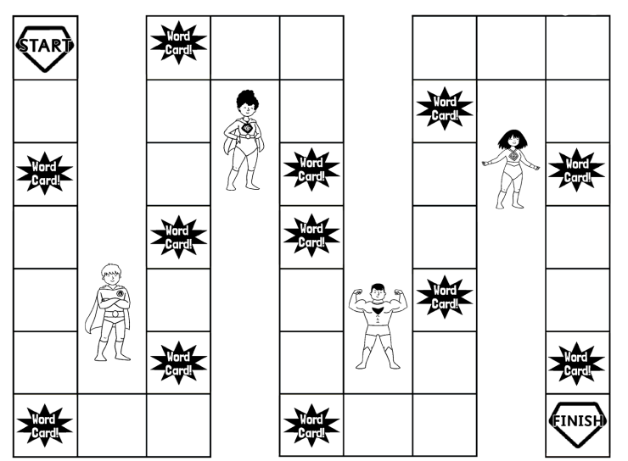

**Instructions**

This is a two player game.

Each player takes turn to roll the dice.

If a player lands on the ‘Word Card’ square, the other player must ask them to spell one of the spelling words for this week.

If the player spells the word correctly, they can roll the dice on their next turn.

If the person spells it incorrectly, they miss a turn and must copy out the word 3 times to practise.

Who will make it to the finish line first?