Using the sunflower worksheet, either write or stick the spelling words in each leaf onto the correct sound sunflower.
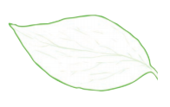
obey
rein
they
afraid
faint
eight
prey
convey
main
survey
beige
claim
brain
sleigh
vein
grey
gre
straight
weight

