I can apply the column method when subtracting 2 digit numbers from 2 digit numbers (crossing 10)
Q1. Copy the number sentence out and use the column method to solve them.
- 34-17= b) 42-29= c) 76-58= d) 63- 37=

e) 92-45= f) 65-49= g) 90-26= h) 67-39=

Q2. Complete the word problems below.
- Jack baked 33 cakes. He sold 18 at the school fair. How many does he have left?

- Year 3 needed 72 sheets of paper for their maths lesson. Only 38 sheets printed out. How many are they missing?

- Rashid has 54 cars. Alex has 82. How many more cars does Alex have than Rashid?

Q3. Tommy is working out 53-25.
Do you agree with his method? Explain your answer.
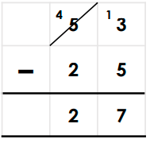
Answer: Do you agree? _________
Prove it:

Explain your answer:
________________________________________________________________________________

