11/12/20 I can subtract crossing 10
- 15 - 7 =

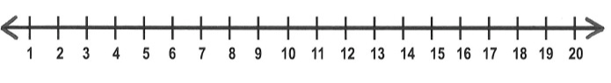
2) 15 - 8 =

3) 16 - 8 =

4) 14 - 9 =

5) 12 - =9

6) 11 - = 5

1/12/20 I can add by making 10 reasoning and problem solving
