**I can understand how to find equivalent lengths – m and cm.**

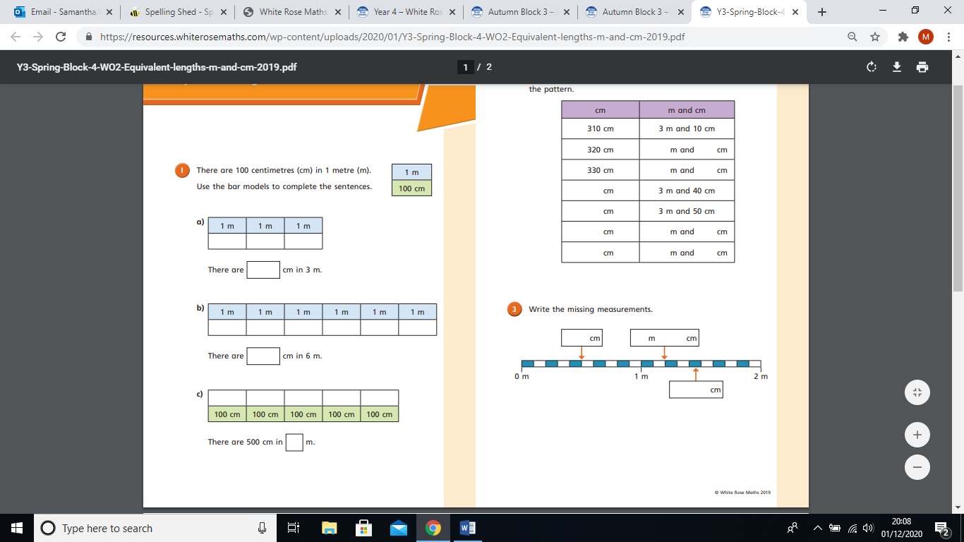

**1.**

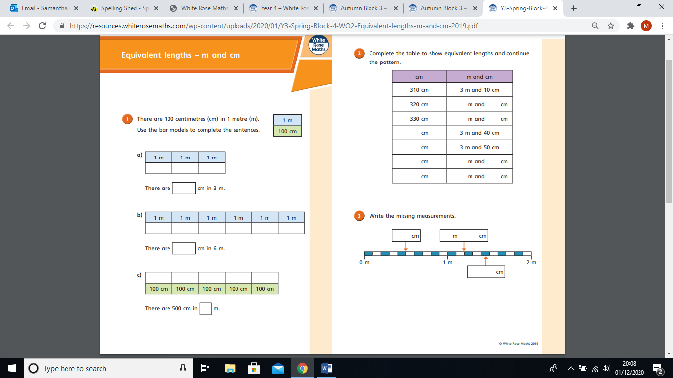

**4.**

**3.**

**2.**

