Monday Top Dinosaurs
Preparation:
Cut up facts and fiction sheet before lesson.
If you have a sand pit or some other way of burying the cards – maybe compost in a box bury the cards if not put them in a box, bowl or envelope.
Activity
Discuss what you already know about dinosaurs and what you would like to find out. On the dinosaur foot prints record 3 things you would like to find out about dinosaurs in this topic. E.g. Did all dinosaurs eat meat?
Pretend to be archaeologists and take turns to uncover the cards from sand or box as appropriate.
Decide between you if they are fact or fiction
Decide how to record - stick on a sheet, blue tac to a board, arrange on carpet and take a photo. Keep so you can see if you were right as we learn.
NB Parents they are currently in order fact then fiction for your information.
Check this work occasionally through the topic to see if any are in the wrong place as you learn more.

Extension If you have time, inclination and resources? – make some dinosaur bones to excavate from salt dough for a dinosaur museum.

Write the questions you would like to research about dinosaurs on these feet. (Don’t forget the question mark!)

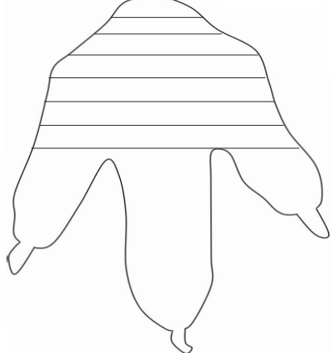

I
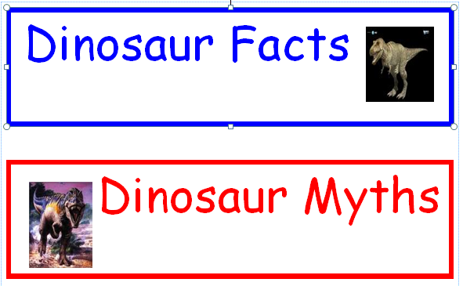

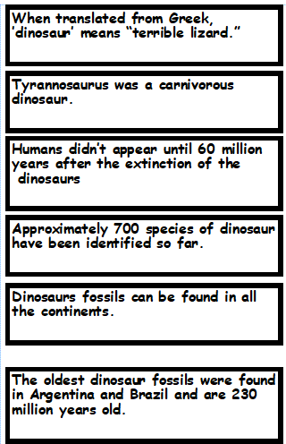
Facts

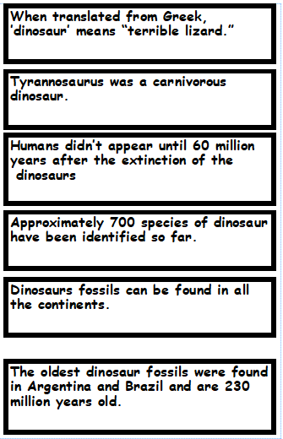

Myths
